Multifractal Medical Image Methodology: Steps

1. Read medical image into Matlab using imread command. Image stored as an array of integers (Array name = A). See figure 1 for example.
2. Prompt user for what size mask to use.
3. Copy array and pad array on edges to a depth the same as mask being used. Uses Matlab command padarray with ‘symmetric’ option (Array name = B)
4. Threshold image to filter out noise (?? Also threshold after polyfit??)
   1. Not implemented yet
5. Apply square mask (see figure 2) or circle mask (see figure 3) to image. For each pixel of the original array (A) located inside the padded array (B) [ie, with x and y values ranging from (1 + depth of mask) to ( length – depth of mask)]
   1. Calculates mean, min, max, range, median, and standard deviation for array of values at current distance. Add each value to its own array.
   2. After going through all depths of mask, stores polyfit (slope) of log-log plot of distance from pixel vs mean, min, max, range, median, and standard deviation at that distance
   3. Place result of polyfit at that pixel into a new image. Separate new slope images are thus formed for mean, min, max, range, median, and standard deviation.
6. After passing all pixels through mask, display slope images for mean, min, max, range, median, and standard deviation. See figures 4-6 for examples.

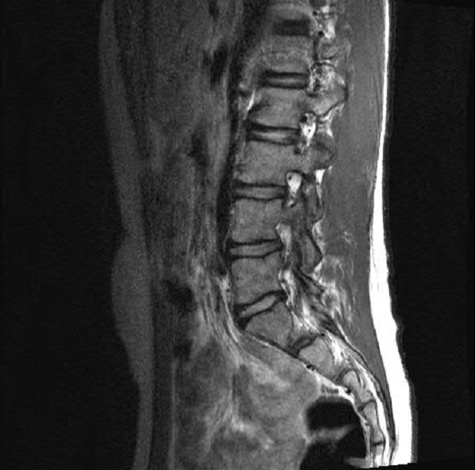

*Figure 1: Original MRI image read into program.*

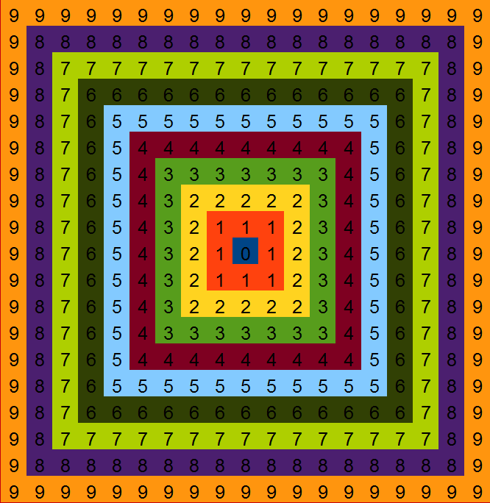

*Figure 2: Square Mask with distances used in calculations*

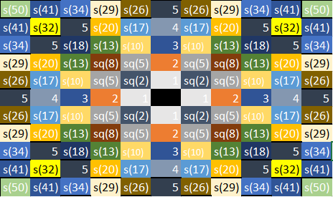

*Figure 3: Circle Mask with distances used in calculations*

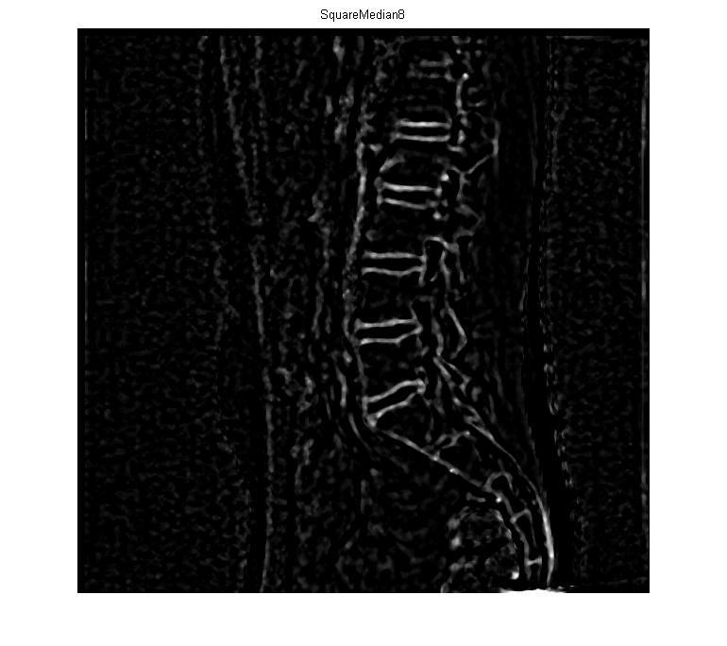

*Figure 4: Slope image of median using square mask at distance 8.*

*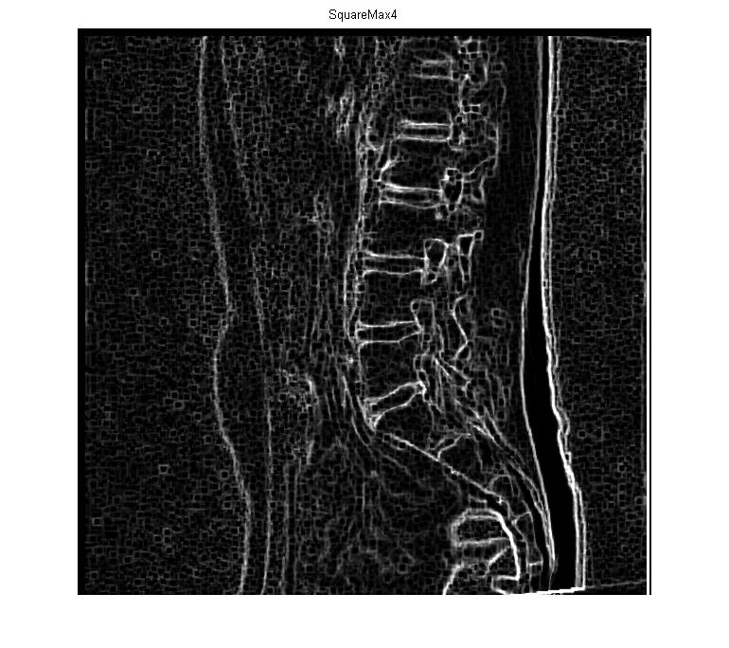*

*Figure 5: Slope image of max using square mask at distance 4.*

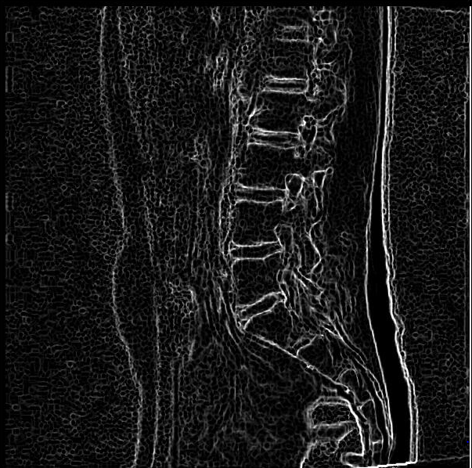

*Figure 6: Slope image of max using circle mask at distance 8.*